Peace Education Result

Date | 17,February, 2022 | Country | Croatia
Place | Slavonski Brod, Croatia | School type | Primary school
Lesson | Peace Education lesson 9 and 10

□ Student reaction
Name | Content
 | Before class | After class
Lucija | I don’t know what is heritage | Through today's class, I learned that heritage is what we leave to our children when we are older.
Andrija | I don’t know how to help older people | Today I learned I can help my grandparents, be with them, listen to them. I can help my neighbors by going to the store or just ask how they are.

□ Teacher's opinion.
Content
Through this class, students will know why we should be polite to our parents/teachers, practicing filial piety and respectful. Find elder people around me and show respect. Recognize human heritage and explains its value.
Know that the best cultural heritage is world peace and must be inherited to future generations.
□ Class Photo
Photo 1 | Photo 2
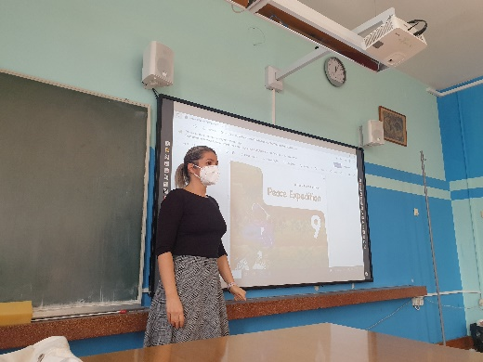 | 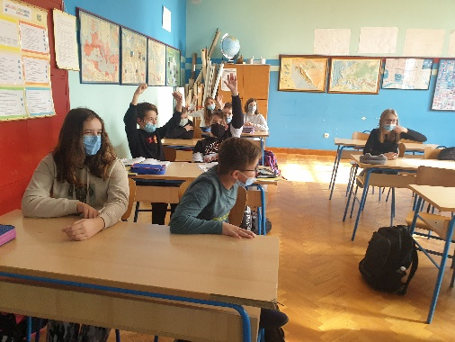
Photo 3 | Photo 4
