Peace Education Result

Date | 10th February 2022. | Country | Croatia
Place | Slavonski Brod, Croatia | School type | Primary school
Lesson | Peace Education lesson 8

□ Student reaction
Name | Content
 | Before class | After class
Petar | I don’t know what is understanding | Through today's class, I learned that understanding is when you put yourself in someone else’s shoes.
Anđelina | I don’t know how can I practice forgiveness | Today I learned that even small things matter, when my sister is not good to me, if I forgive her, I can feel better.

□ Teacher's opinion.
Content
Through this class, students will understand the meaning of forgiveness and perceiving the relationship between forgiveness and
peace. They will understand the need for forgiveness through a variety of cases.
And they will apply forgiveness in one’s own life and finding methods of practice
□ Class Photo
Photo 1 | Photo 2
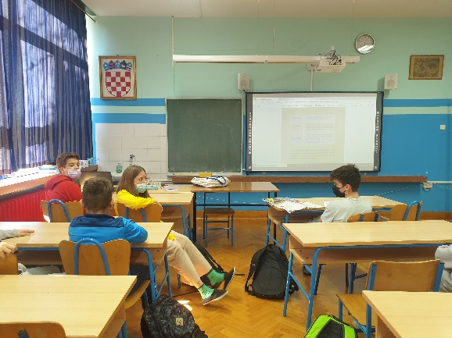 | 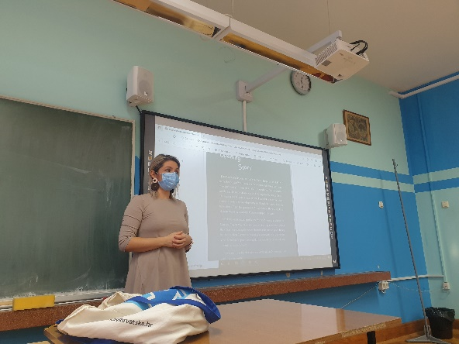
Photo 3 | Photo 4
