Peace Education Result

Date | 3rd February 2022. | Country | Croatia
Place | Slavonski Brod, Croatia | School type | Primary school
Lesson | Peace Education lesson 7

□ Student reaction
Name | Content
 | Before class | After class
Andrija | I don’t know what is sacrifice | Through today's class, I learned that sacrifice when you do something good for someone else.
Mijo | I don’t know you can be happy by doing sacrifice | Today I learned that I when I help my football team win, I feel very good even though I got very, very tired.

□ Teacher's opinion.
Content
Through this class, students understand that sacrifice is the basis to achieve peace, and the value of sacrifice through various examples and have the heart to practice sacrifice.
□ Class Photo
Photo 1 | Photo 2
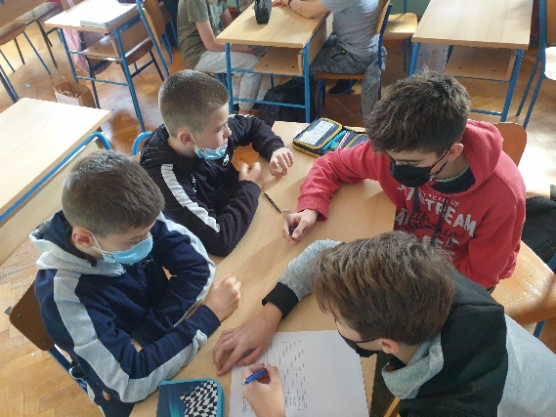 | 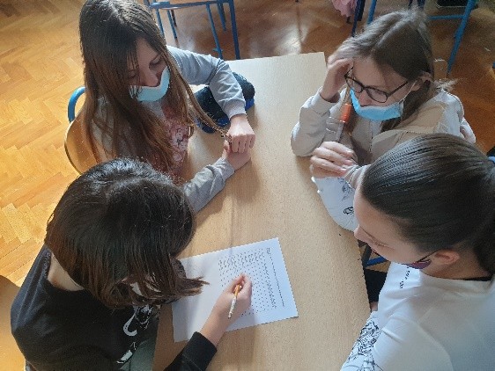
Photo 3 | Photo 4
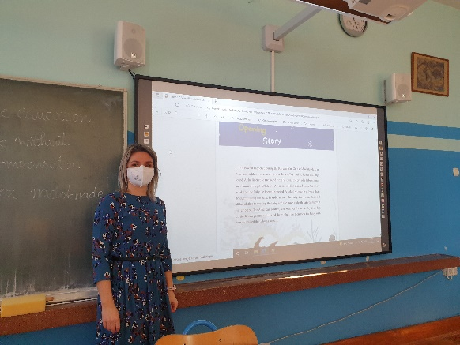 | 