Peace Education Result

Date | 13,January, 2022 | Country | Croatia
Place | Slavonski Brod, Croatia | School type | Primary school
Lesson | Peace Education lesson 6

□ Student reaction
Name | Content
 | Before class | After class
Elena | I don’t know what considerate means | Through today's class, I learned that considerate is someone who helps others.
Petar | I don’t know how I can be considerate | Today I learned that I can be considerate when I ask my friend how he is, when I see he is not OK.
Anđelina | I don’t know how consideration and peace are connected | I found out that without consideration for other people we can not live in peace.

□ Teacher's opinion.
Content
Through this class, students understand the concept and importance of consideration, they understand the benefits that derive from being considerate through examples. Students also understand that everyone needs to be considerate for peace in a community and learn how to apply it.
□ Class Photo
Photo 1 | Photo 2
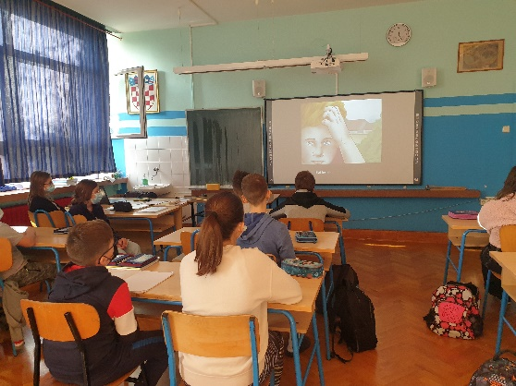 | 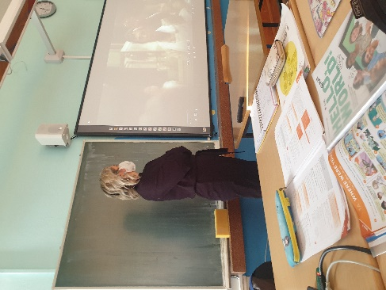
Photo 3 | Photo 4
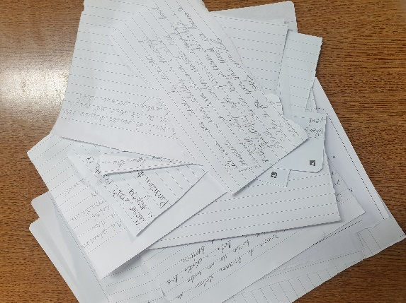 | 