Peace Education Result

Date | 23,December, 2021 | Country | Croatia
Place | Slavonski Brod, Croatia | School type | Primary school
Lesson | Peace Education lesson 5

□ Student reaction
Name | Content
 | Before class | After class
Karlo O.R. | I don’t know what grateful is | Through today's class, I learned that being grateful is important, I am grateful for my family and friends
Andrija | I don’t know what I am grateful for | Today I learned that I am grateful for going to school, many children can not do that, they are in war.

□ Teacher's opinion.
Content
Through this class, students understand that being grateful starts with remembering what has been given to me. They understand the necessity of being grateful and the benefits of being grateful. They talk about specific ways to express gratitude and practice it to establish the characteristics of peace.
□ Class Photo
Photo 1 | Photo 2
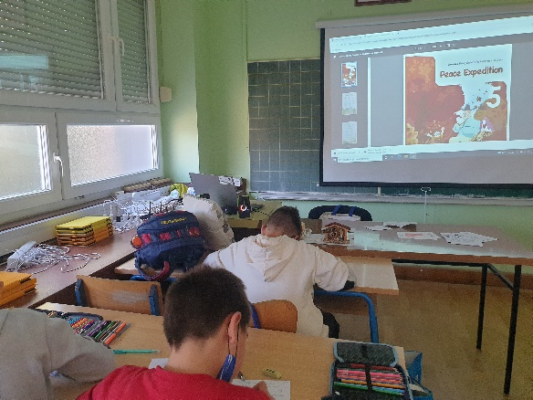 | 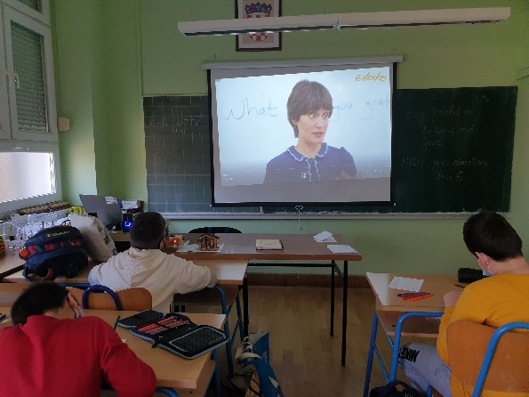
Photo 3 | Photo 4
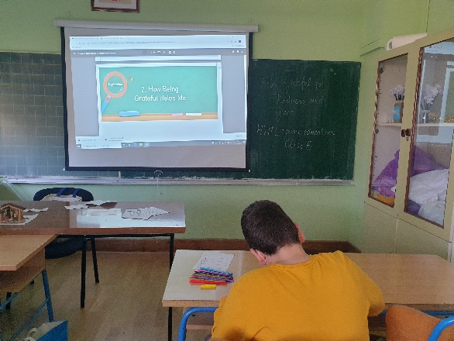 | 