Peace Education Result

Date | 3.3.2022. | Country | Croatia
Place | Slavonski Brod, Croatia | School type | Primary school
Lesson | Peace Education lessons 11 and 12

□ Student reaction
Name | Content
 | Before class | After class
Tena V. | I don’t know what can I do to make peace | Through today's class, I learned that I can make peace in my family and in my class. I can be the one to help my friends if they are fighting.
Luka | I don’t know if I can be courageous | Today I learned that all that I do matter. And I can be brave doing small thing in the name of peace.

□ Teacher's opinion.
Content
In this class students will learn and understand the law-abiding spirit through the necessity of law. They will understand that one needs to have traits of peace in order to observe law and that a binding law of peace is needed to achieve peace. Students will also learn that realizing peace requires courageous actions. They will understand that the love for peace becomes the engine for achieving peace and that they are the answer to realizing peace and be determined to take part in peace work
□ Class Photo
Photo 1 | Photo 2
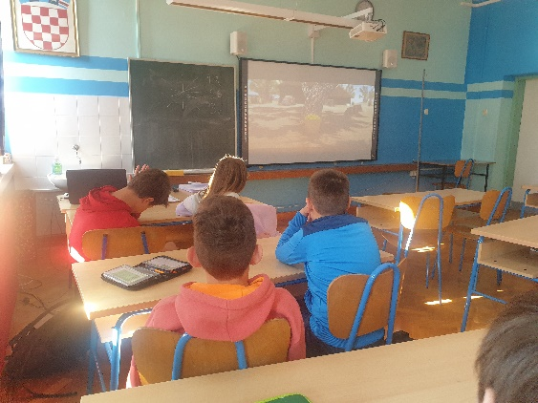 | 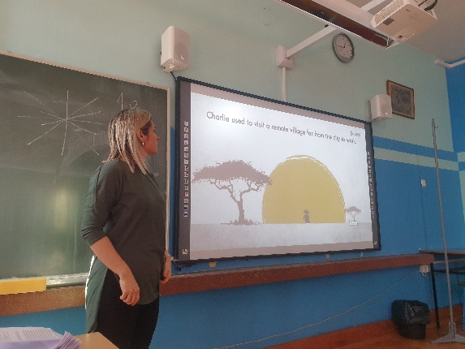
Photo 3 | Photo 4
