Peace Education Result

Date | 15,December, 2021 | Country | Croatia
Place | Slavonski Brod, Croatia | School type | Primary school
Lesson | Peace Education lesson 4

□ Student reaction
Name | Content
 | Before class | After class
Ivan J. | I don’t know what is order | Through today's class, I learned that order is important in nature, like in the hole world.
Lucija V. | I don’t know what global community is | Today I learned that I when we all help each other, and work as a team we can have peace and order. I can start helping my neighbours.

□ Teacher's opinion.
Content
Through this class, students understand that there is order in the creation of nature, and importance of the order in humanity. They found out that the peace begins with one person.

□ Class Photo
Photo 1 | Photo 2
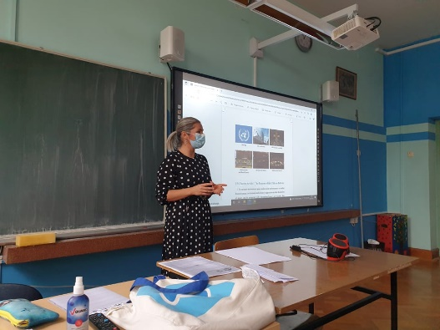 | 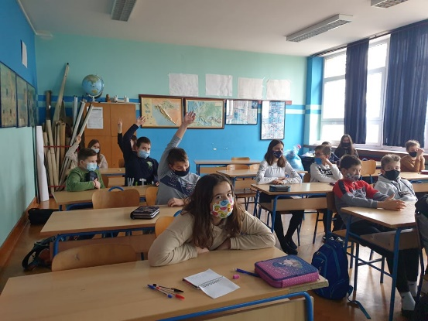
Photo 3 | Photo 4
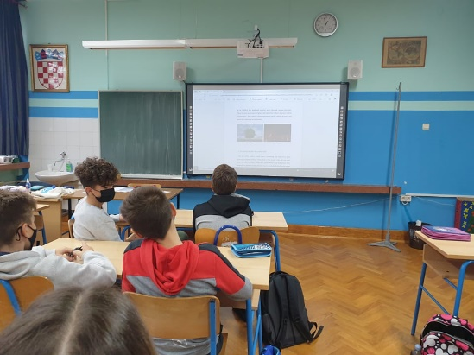 | 