Peace Education Result

Date | 25, November, 2021 | Country | Croatia
Place | Slavonski Brod, Croatia | School type | Primary school
Lesson | Peace Education lesson 2

□ Student reaction
Name | Content
 | Before class | After class
Mihovil | I don’t know what is harmony. | Through today's class, I learned that harmony is very important for us to live in peace.
Tena V. | I don’t know which example to say about my role in school. | I can help my friends with homework, and they can do the same when I need it.

□ Teacher's opinion.
Content
Today children found out why all creation live in harmony, what harmony is and why is it important to us. The children found out first their value and than their role in school and at home.
□ Class Photo
Photo 1 | Photo 2
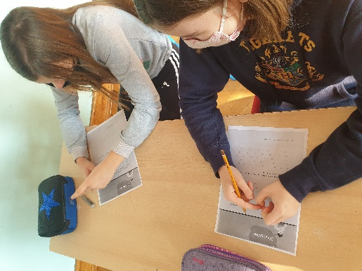 | 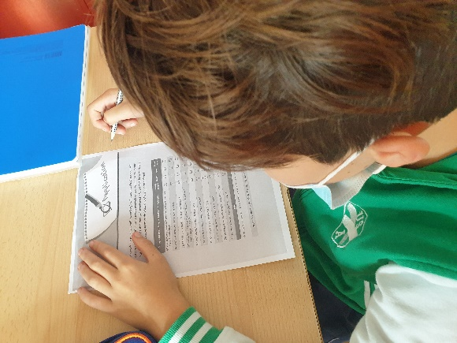
Photo 3 | Photo 4
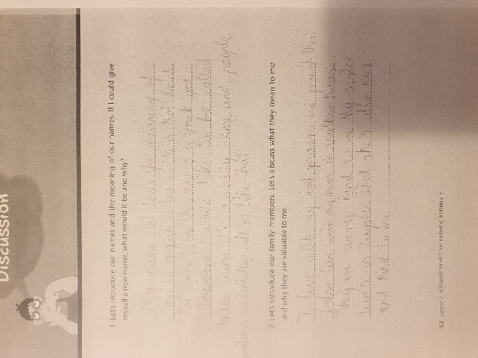 | 