Peace Education Result

Date | 11, November, 2021 | Country | Croatia
Place | Slavonski Brod, Croatia | School type | Primary school
Lesson | Peace Education lesson 1

□ Student reaction
Name | Content
 | Before class | After class
Tea | I don’t know what is diversity | Through today's class, I learned that I we are all different, but that is ok.
Borna | I don’t know which example to say about harmony | Today I learned that friends can be different, but still get along well.
Lucija V. | I don’t know what is cooperation | Today I learned that animals and plants live in harmony and cooperation in the nature.

□ Teacher's opinion.
Content
Today children found out that all creation maintains diversity and works together to establish harmony. They know now where to seek answers for world peace from the original state of all creation.
□ Class Photo
Photo 1 | Photo 2
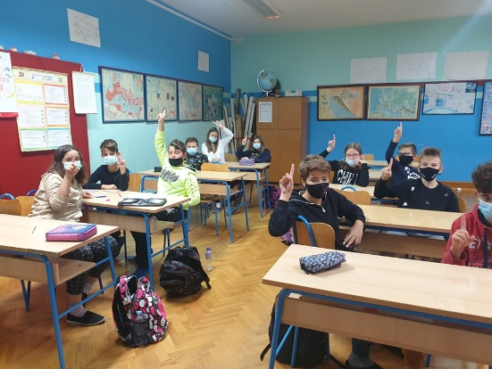 | 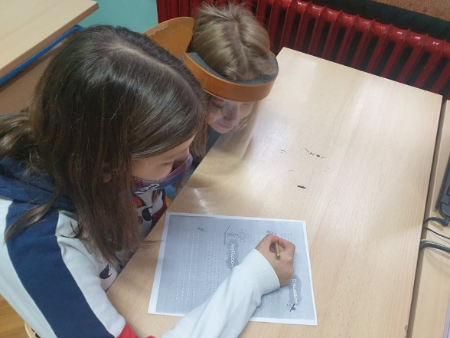
Photo 3 | Photo 4
